This document contains all the pictures that are used in the powerpoint because a lot of pictures are overlapped due to animations.

In human body, heart rate is affected by the effects of SNS/PNS

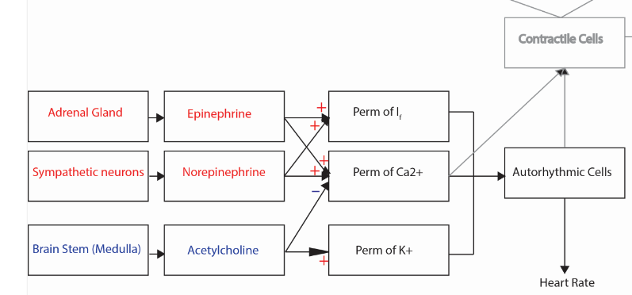

In simulink, we are modeling the membrane potential of purkinje fibres. However, PNS and SNS primarily innervate SA node. Therefore, we have modeled the frequency of SA node and relayed the frequency to purkinje fibres and subsequently produce appropriate membrane potential of purkinje fibre with corresponding frequency.

Parasympathetic

Nervous System

Sympathetic

Nervous System

Sinoatrial

node

Atrioventricular

node

Purkinje

Fibre

Class 1A

Anti-arrhythmic

drug

Overall simulink model:

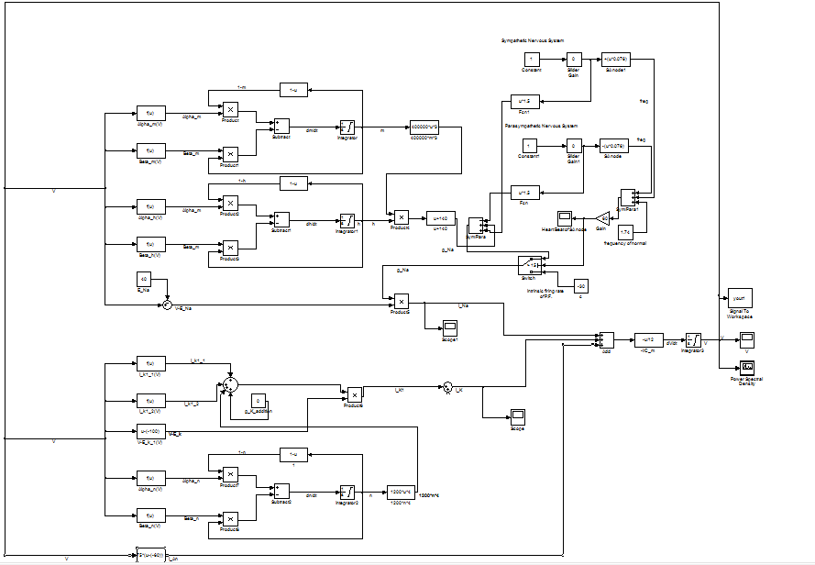

Inputs to the Noble model (part of our modification)

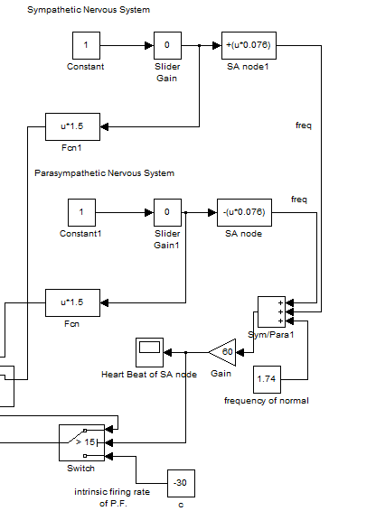

No Inputs

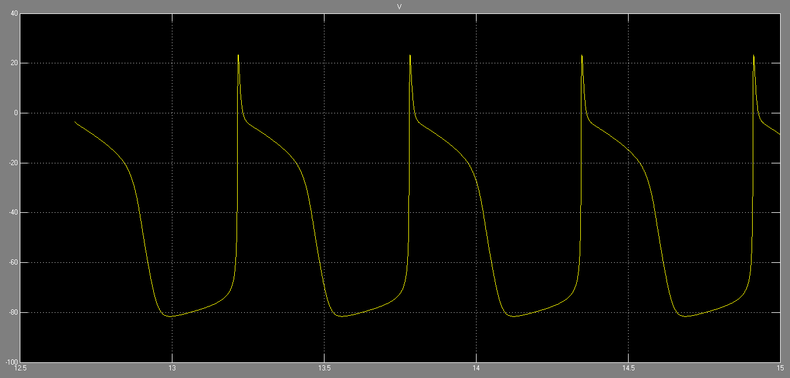

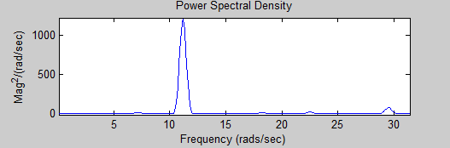

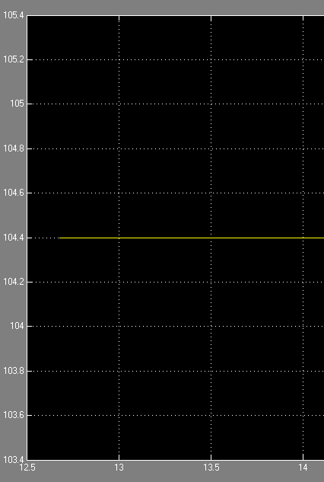

Sym 5

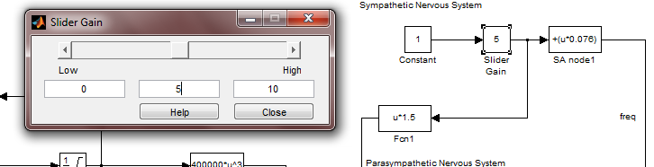

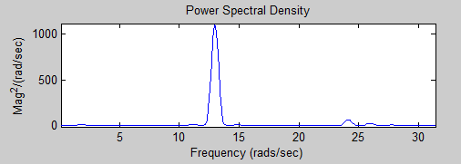

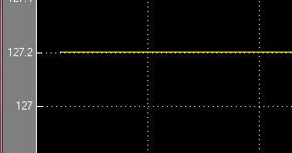

Sym 10

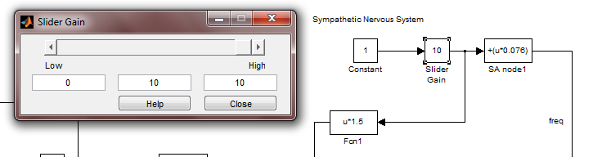

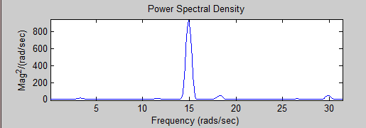

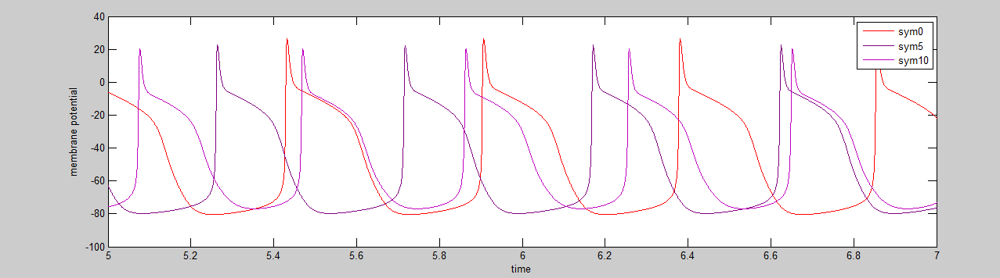

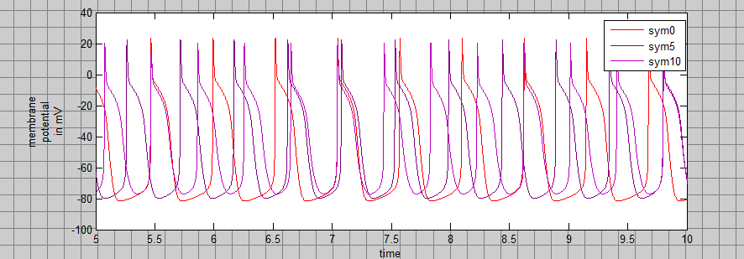

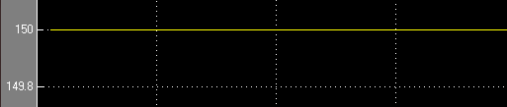

Para sym 5

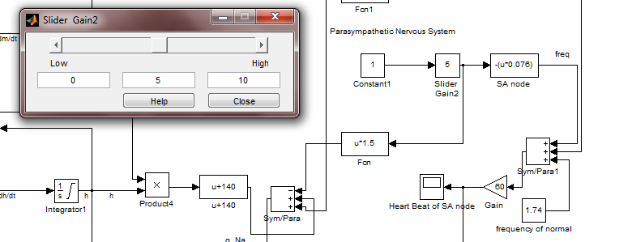

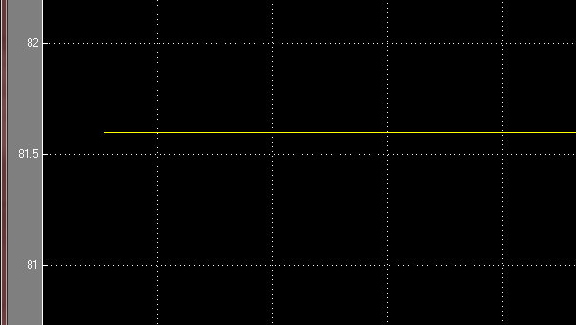

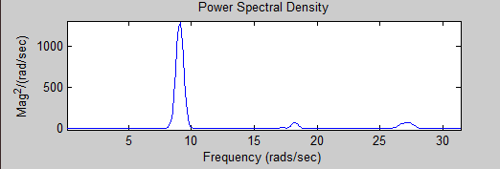

Para_sym_10

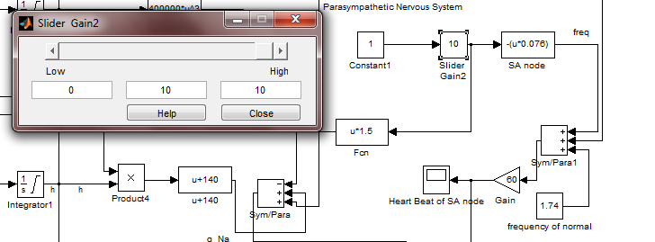

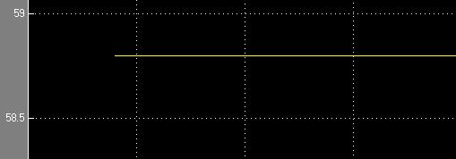

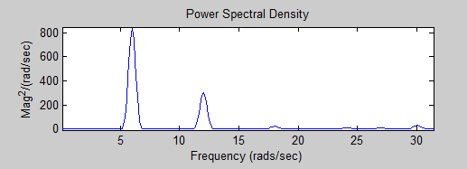

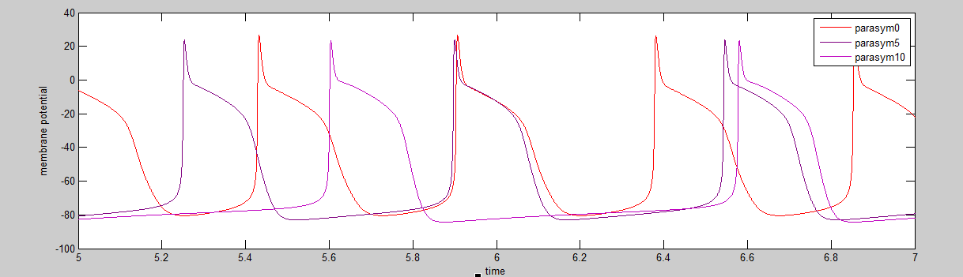

We Can also change potassium to model heart rate.

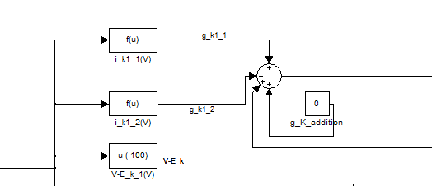



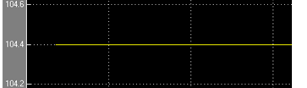

g_k addition of 60

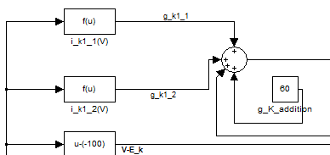

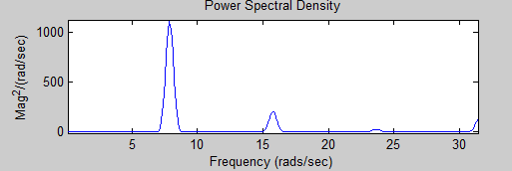

g_k addition of -60

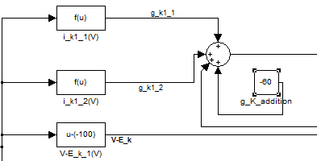

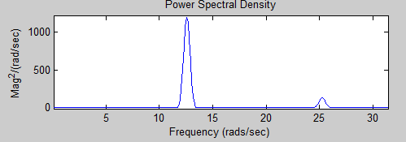

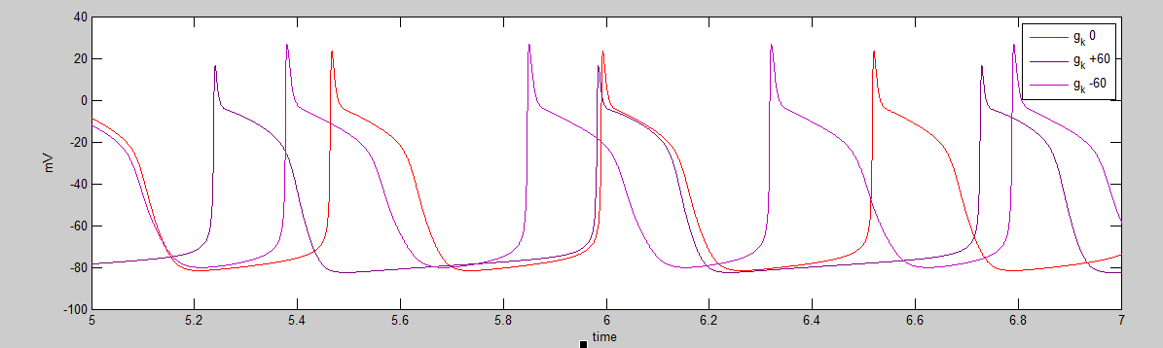

Equations used [1]:

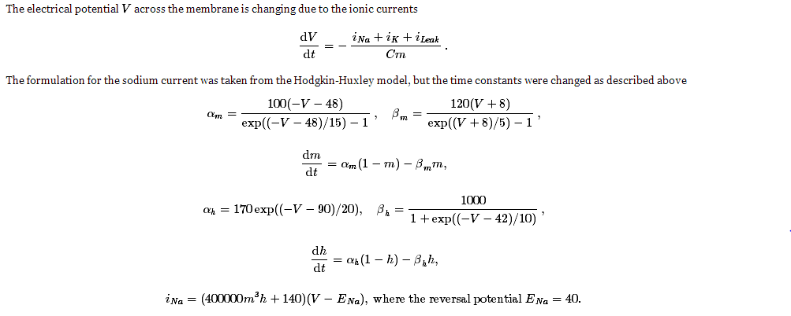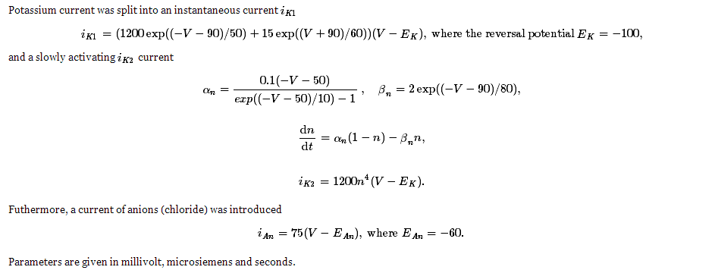

Graphs/Tables used for Class 1A Antiarrhthmic Drugs:

-Portion of block diagram corresponding to fast sodium channel membrane conductance.

-Equation governing sodium membrane conductance is 400000*m*3*h*+140.

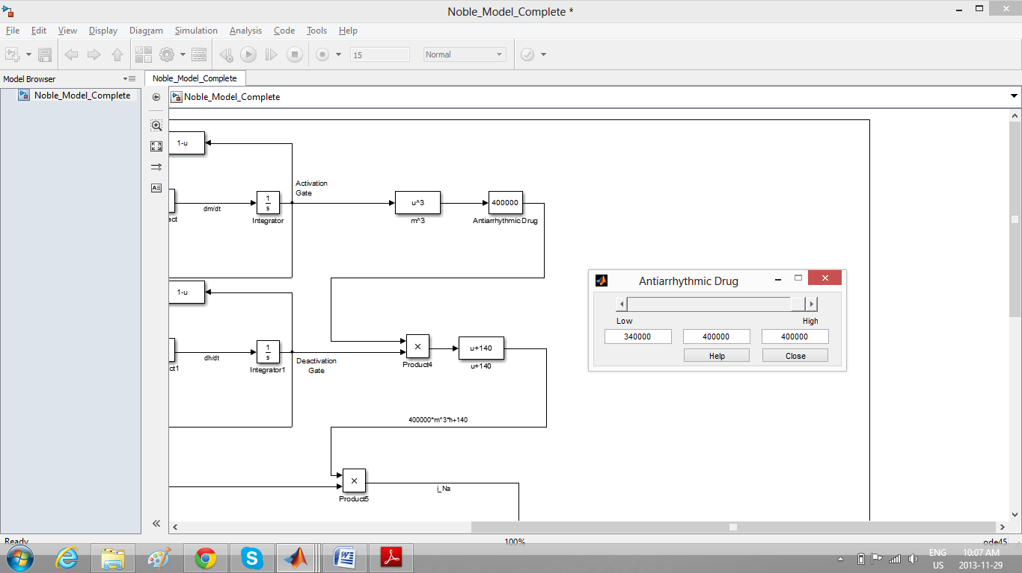

-Frequency spectrum:

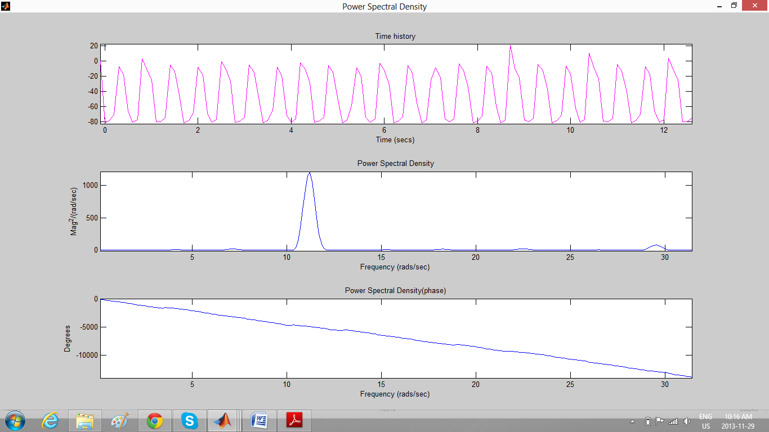

-Block diagram corresponding to modelling drug effect by changing gain to 340000 in the sodium membrane conductance governing equation: 340000*m*3*h*+140

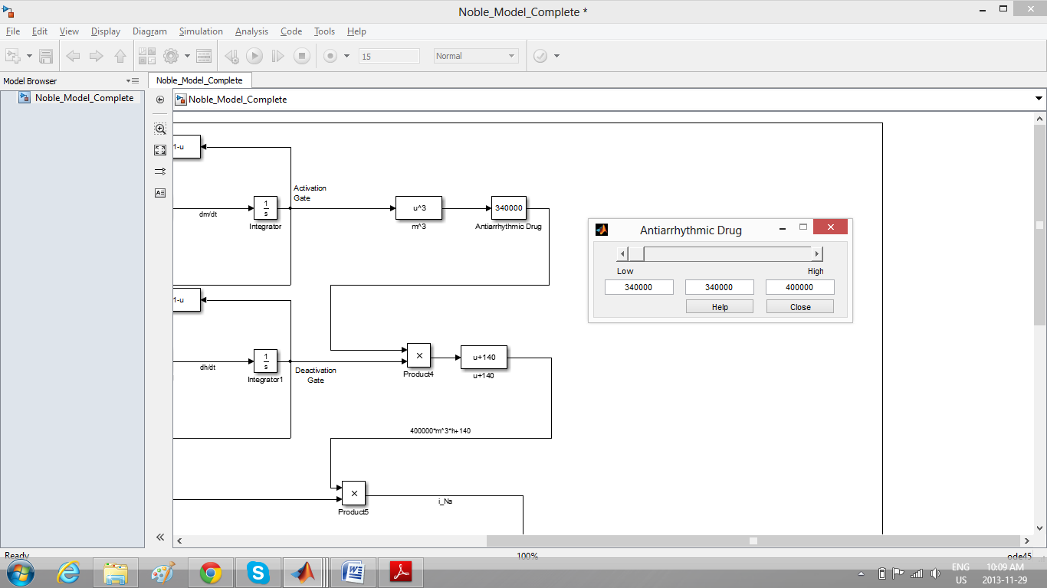

-Frequency spectrum:

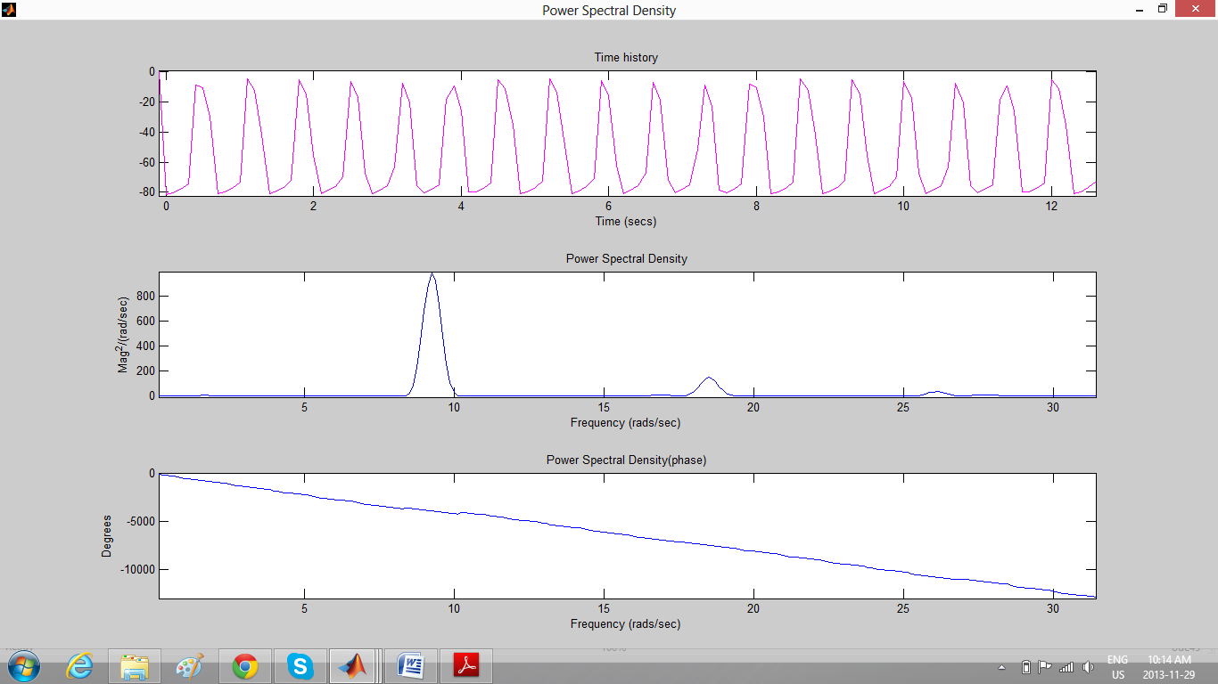

-Block diagram corresponding to modelling drug effect by changing gain to 370000 in the sodium membrane conductance governing equation: 370000*m*3*h*+140

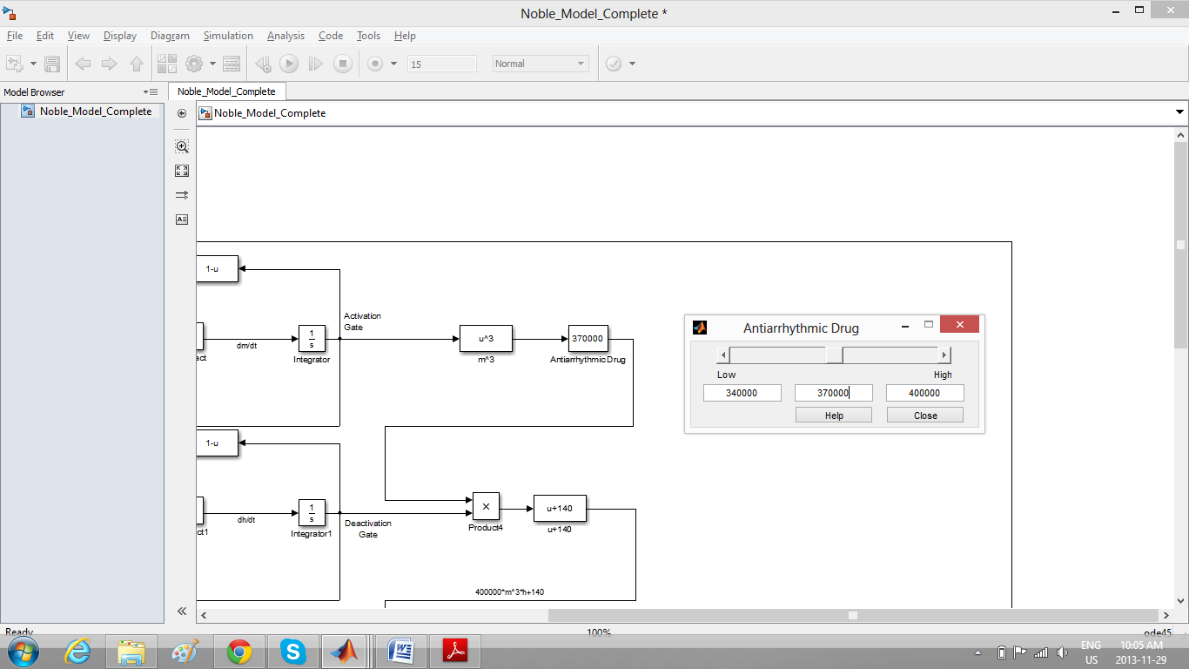

-Frequency spectrum:

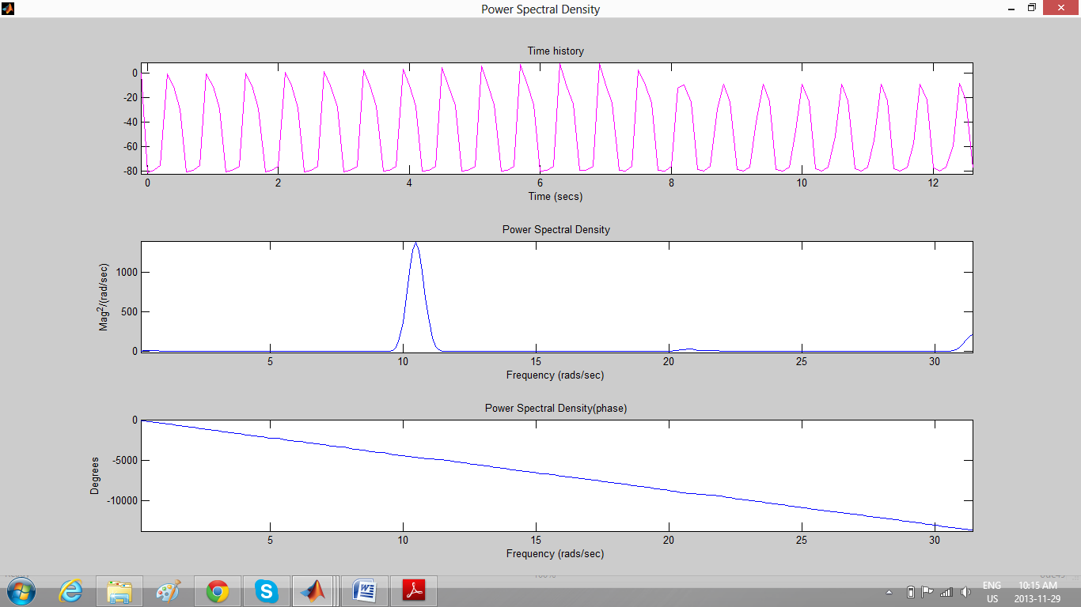

-Table corresponding to how heart rate is changed in response to change in gain

|  |  |
| --- | --- |
| Gain | Heart Rate Per Minute |
| 340000 | 88 |
| 350000 | 94 |
| 360000 | 97 |
| 370000 | 99 |
| 380000 | 101 |
| 390000 | 103 |
| 400000 | 106 |

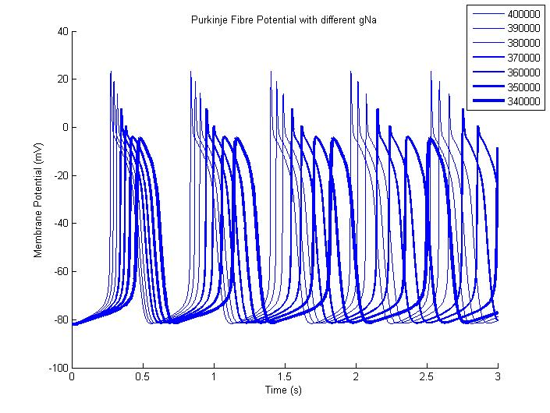

-Code for generating the plot

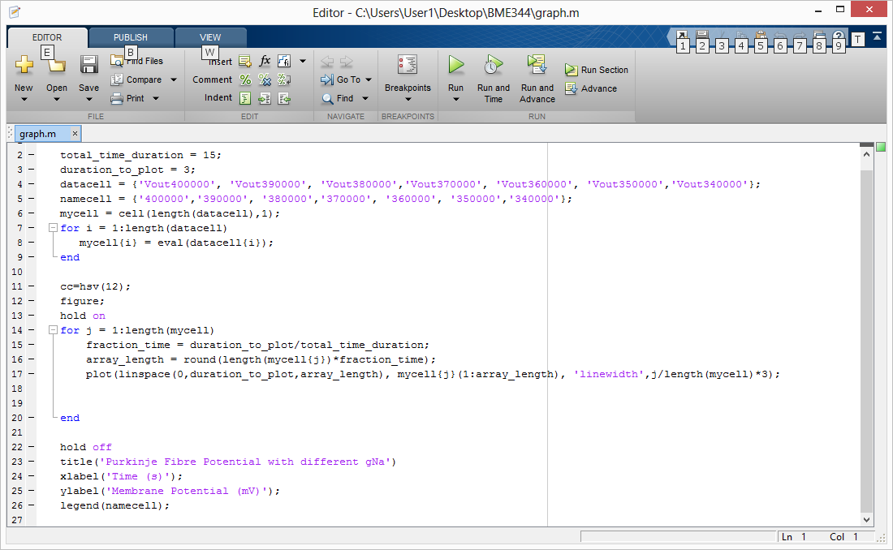

Effect of drug on Purkinje fibre membrane potential

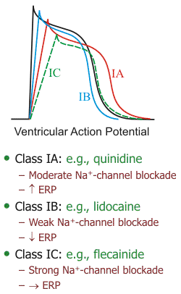

# Works Cited

|  |  |
| --- | --- |
| [1] | D. Noble, "Noble Model," Scholarpedia, [Online]. Available: http://www.scholarpedia.org/article/Noble_model. [Accessed 10 Nov 2013]. |
| [2] | N. D, "A modification of the Hodgkin-Huxley equations applicable to purkinje fibre action and pacemaker potentials," *J Physiology,* pp. 317-352, 1962. |